ASP.NET Based Tic-Tac-Toe Game
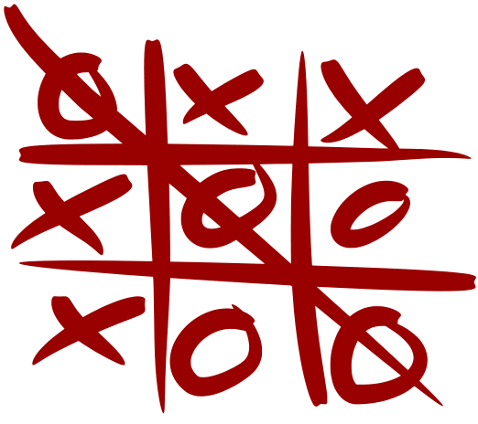
Create an ASP.NET Web application to play the classical Tic-Tac-Toe puzzle game with two players who play one against the other.
The application should allow to all visitors (without authentication) to view / create / join a game:
- View a list of all games that are waiting for a second player
- Create new game (as a first player)
- Join an existing game (as a second player)
Once a game between two players (sitting at different machines) is successfully started, the players are allowed to play their turn one after another until the game finishes.
- When the current player should move, he / she should click at some of the empty game fields and in the same time the other player is waiting.
- When it is the other player's turn, the current player waits for his / her response.
- When the game is finished (win / loss / drawn game), both players are notified and are allowed to visit the initial page to view / create / join a game.

Additional Requirements
- You should use ASP.NET Web Forms and C#.
- Note that two players play one against the other and you don't need to implement logic for playing against the computer.

Hints
- It is a good idea all to give all game sessions a unique identifier (GUID).
- You could keep the game boards at the server side, in the ASP.NET Application object (in a Dictionary<Guid, GameBoard>).
- The game board GUID associated with the current player could be kept in the ASP.NET Session object or could be passed as hidden form value.

